API Fetch Data (Loading & Rendering)

This project is based on newly release Next.js react framework Next.js 13 it had new features such as page and layout

This App fetch data from the given url and rendered on the document

The page.js in the app directory will works as a home page, page.js is the new feature that provides routing through directory each and every folder contain page.js file when click to the link will routed to respected page folder.

Project Folder tree Structure

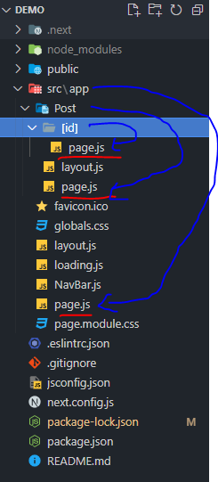

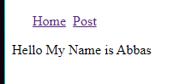

Code

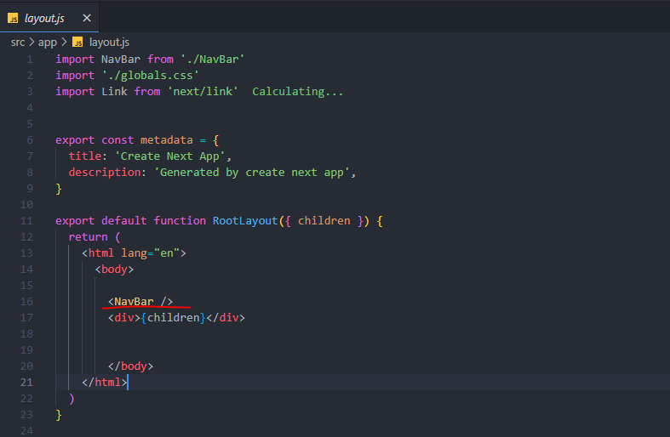

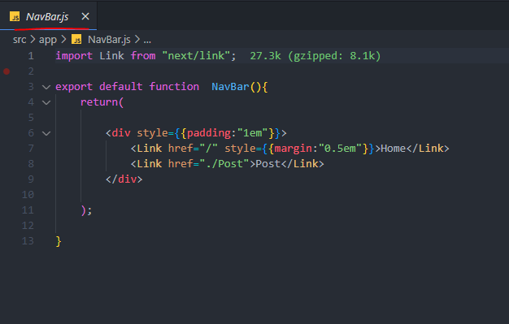

Home Post is coming from NavBar.js file

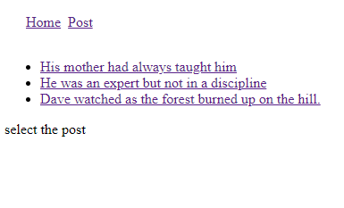

When click to the post link the Post/page.js will render without re-rendering the whole page again.

Code:

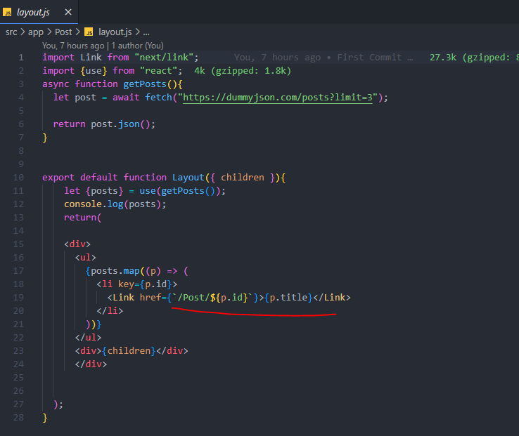

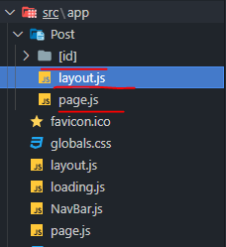

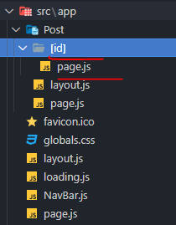

A Dynamic Segment can be created by wrapping a folder's name in square brackets: [folderName]. For example, [id] or [slug].

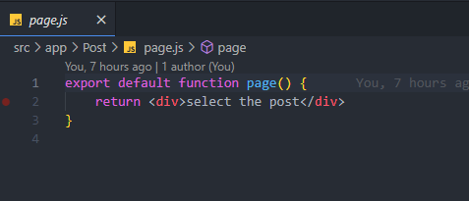

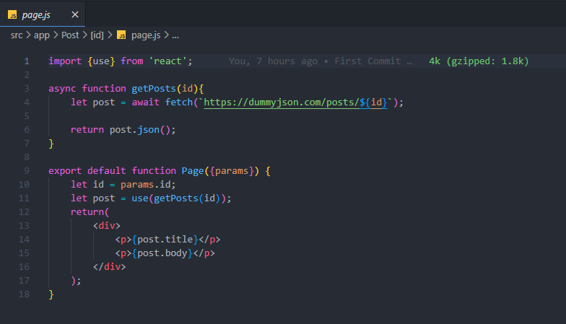

Github project link: <https://github.com/Rizvi-Ahmed-Abbas-Nasir/Next.js-API-Fetch-From-Server-Loading-Rendering->